1.      Create AFTER UPDATE trigger to track product price changes

Create product_price_audit table with below columns:  
audit_id SERIAL PRIMARY KEY,

    product_id INT,

    product_name VARCHAR(40),

    old_price DECIMAL(10,2),

    new_price DECIMAL(10,2),

    change_date TIMESTAMP DEFAULT CURRENT_TIMESTAMP,

    user_name VARCHAR(50) DEFAULT CURRENT_USER

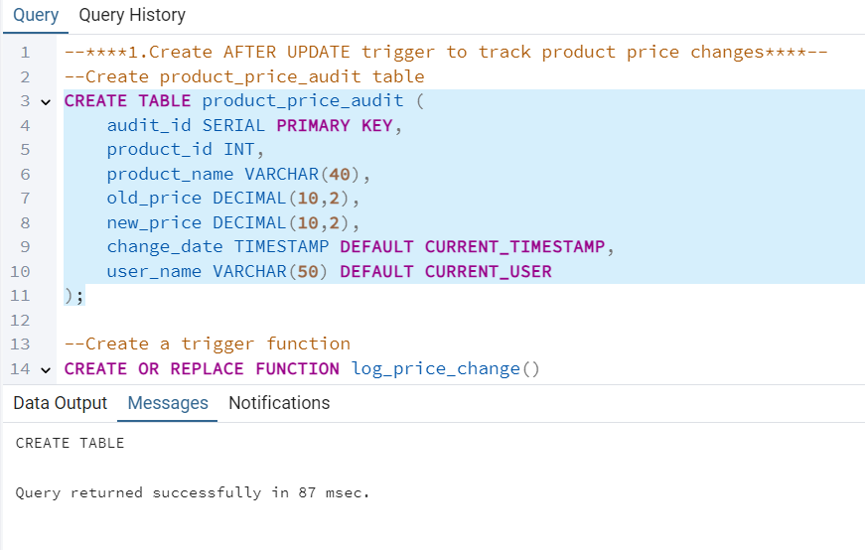

Create a trigger function with the below logic:

 INSERT INTO product_price_audit (

 product_id,  
 product_name,

 old_price,

 new_price  )

    VALUES (  
OLD.product_id,  
OLD.product_name,        OLD.unit_price,

        NEW.unit_price

    );

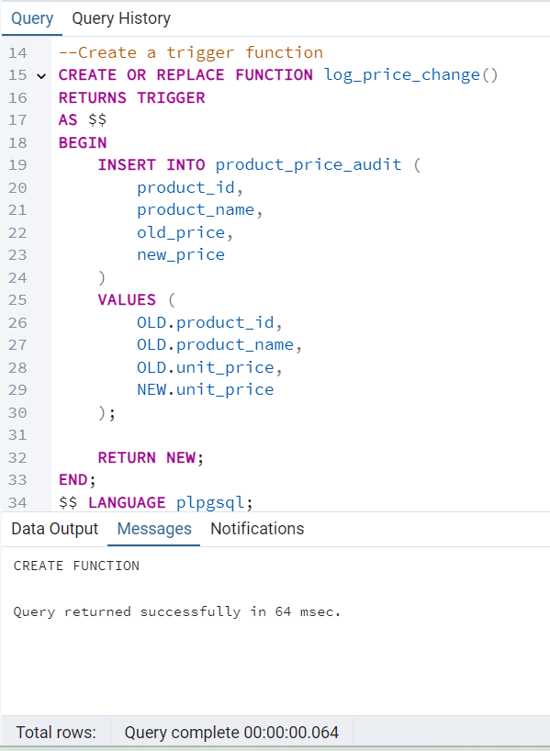

Create a row level trigger for below event:

           AFTER UPDATE OF unit_price ON products

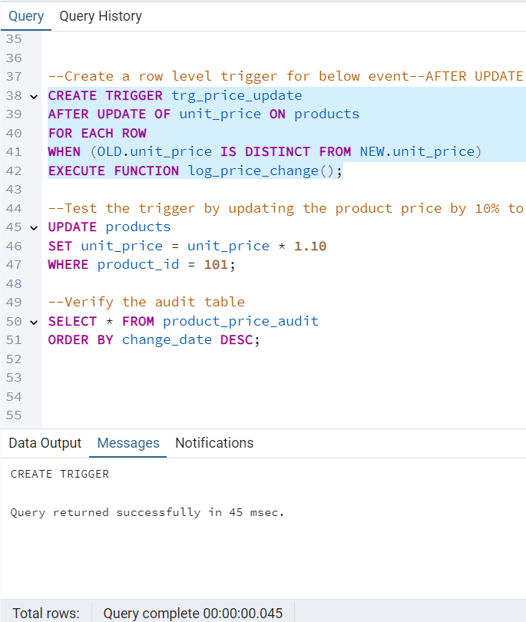

Test the trigger by updating the product price by 10% to any one product_id.

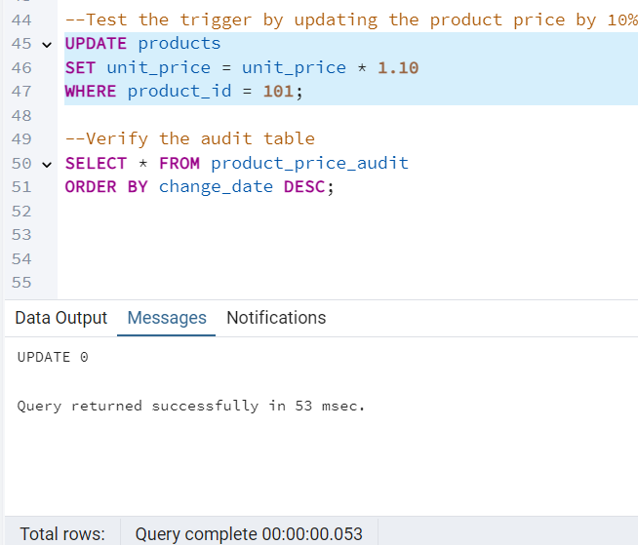

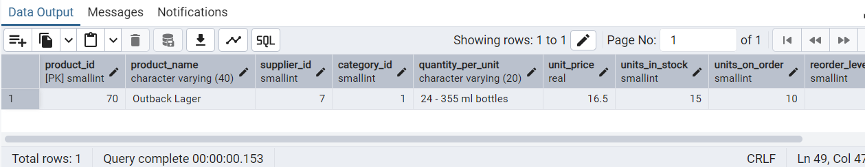 Verifying the audit_table:

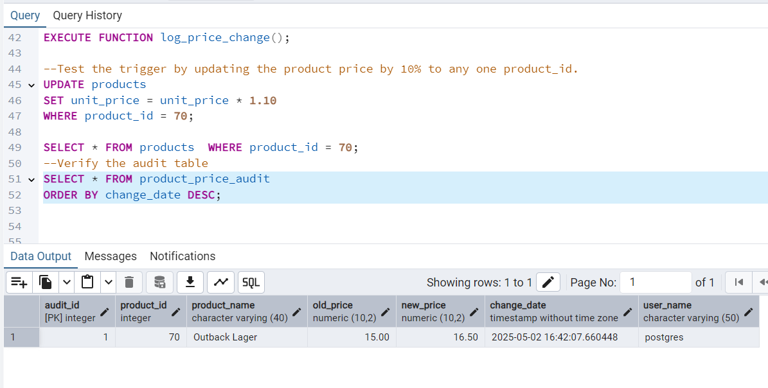  
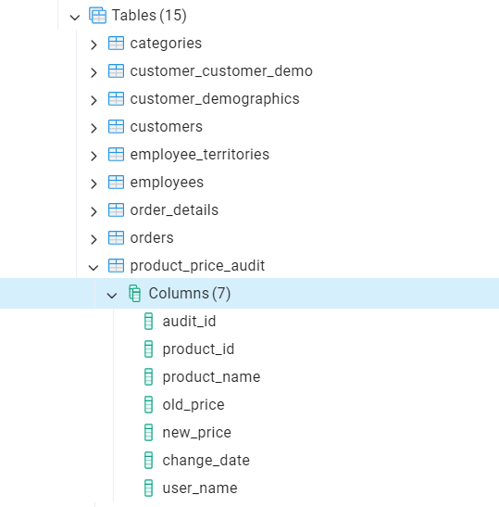

2.      Create stored procedure  using IN and INOUT parameters to assign tasks to employees

   Parameters:

IN p_employee_id INT,

IN p_task_name VARCHAR(50),

 INOUT p_task_count INT DEFAULT 0

Inside Logic: Create table employee_tasks:

 CREATE TABLE IF NOT EXISTS employee_tasks (

        task_id SERIAL PRIMARY KEY,

        employee_id INT,

        task_name VARCHAR(50),

        assigned_date DATE DEFAULT CURRENT_DATE

    );

 ·       Insert employee_id, task_name  into employee_tasks

·       Count total tasks for employee and put the total count into p_task_count .

·       Raise NOTICE message:

RAISE NOTICE 'Task "%" assigned to employee %. Total tasks: %',

        p_task_name, p_employee_id, p_task_count;

